**Sporty Shoes (Phase 3 Project)**

**project description:**

Sporty Shoes is a company that manufactures and sells sports shoes. They have a walk-in store, and now, they wish to launch their e-commerce portal sportyshoes.com.

**Tech stack:**

-> Java(Eclipse)

->Maven Project

-> Spring Boot Application

-> MySql

**Flow chart:**

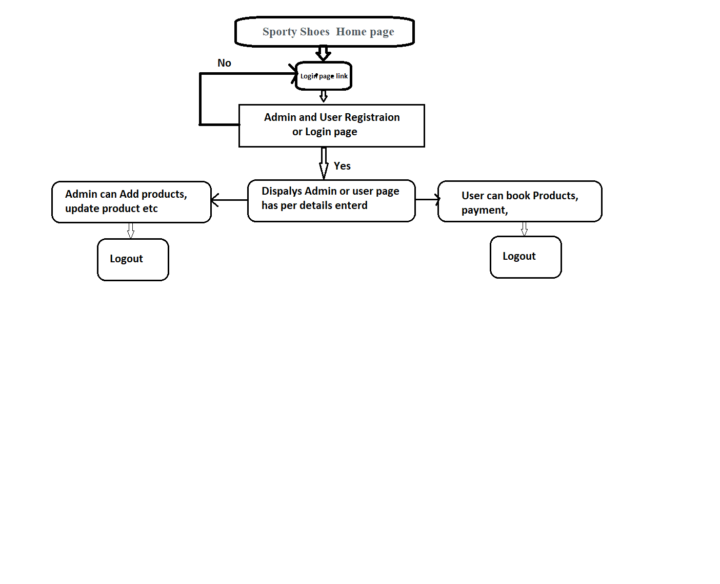

**Sprints :**

I have decided to complete entire project in two sprint.

First sprint to prepare Flowchart and Algorithms. And also planed to use what are software to use.

Second sprint I have implemented code using Eclipse and uploaded to GitHub.

* It requires two sprints to complete the application.
* Product owner: Sporty shoes.com.

**GitHubRepository:**

Git Repository link:**https://github.com/KiranGangal/KiranGangal**